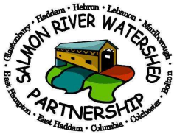
Baseline Water Quality Monitoring Salmon River Watershed Summer 2023 Appendix

